BACSE101 Problem Solving using Python

PROJECT REPORT
on

STUDENT MARK LIST

Prepared by

Karan S Kumar – 25BCE2724

JOSHUA JOEL – 25BCE274

SIDDARTH – 25BCE2745

JAYANTH – 25BCE2750

Under the supervision of
Subhashree Barada



School of Computer Science and Engineering
Vellore Institute of Technology, Vellore.

November 06, 2025
Table of Contents
Abstract
1. Introduction
2. Problem Statement and Objectives
3. Implementation Code
4. Demo Screenshots
5. Conclusion

Abstract
The Student Mark List Management System is a streamlined digital solution designed to efficiently record, manage, and analyse student academic performance. It enables administrators and educators to input marks across subjects, automatically calculate totals and grades, and generate comprehensive reports with minimal manual effort. With features like secure login, search and filter capabilities, and printable mark sheets, the system enhances accuracy, transparency, and accessibility in academic evaluation. Built using technologies such as HTML, CSS, JavaScript, and a backend like PHP or Python with a MySQL database, it offers a scalable and user-friendly platform for educational institutions.

1. Introduction
The Student Mark List Management System is a simple and efficient tool for recording, calculating, and managing student academic results digitally. It helps reduce manual errors and makes performance tracking easier for teachers and administrators.

Domain Information
Subsections can be numbered as 1.1, 1.2, etc

Software Libraries Used
Software libraries used: NumPy, Pandas, Tkinter

Contributions by Team Members

Challenges Faced

2. Problem Statement and Objectives
Objectives of the Student Mark List Management System
1. Digitize Academic Records: Replace manual mark entry with a structured digital system for improved efficiency.
2. Ensure Accuracy: Automate calculations of totals, averages, and grades to minimize human error.
3. Simplify Data Access: Enable quick retrieval of student records through search and filter functions.
4. Support Scalability: Design the system to handle increasing numbers of students, subjects, and academic terms.

3. Implementation

3.1 Feature
Mention separate sections as 3.2, 3.3 and the respective code separately for each feature implemented in the whole project and also be provided as a menu option.

4. Demo Screenshots
Source code:
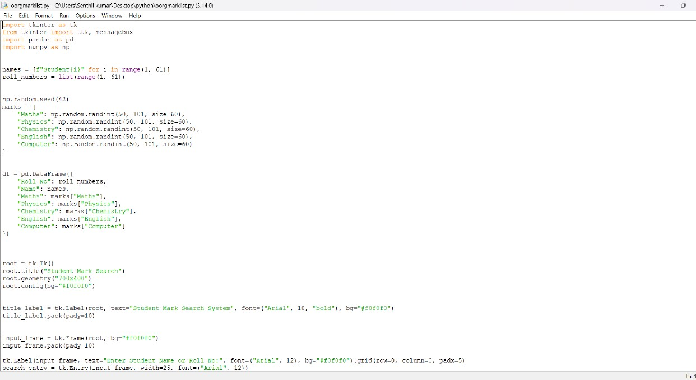

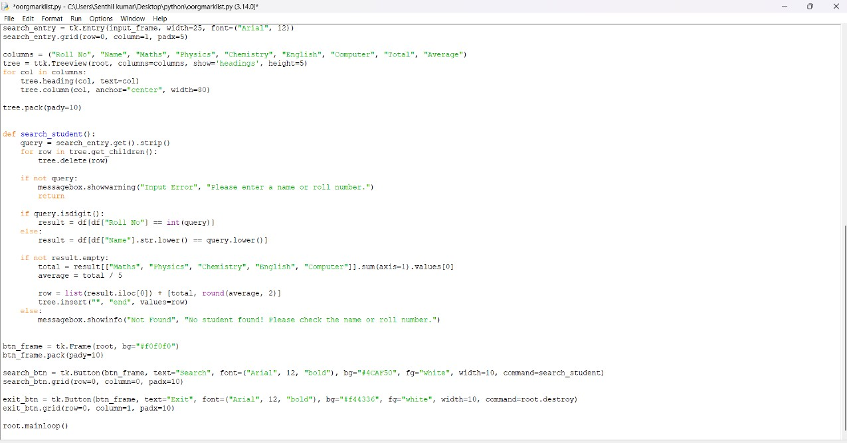

Output: 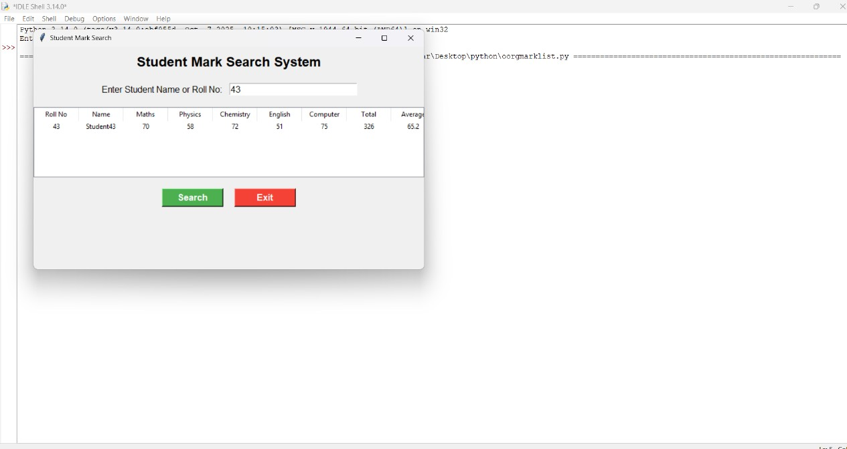

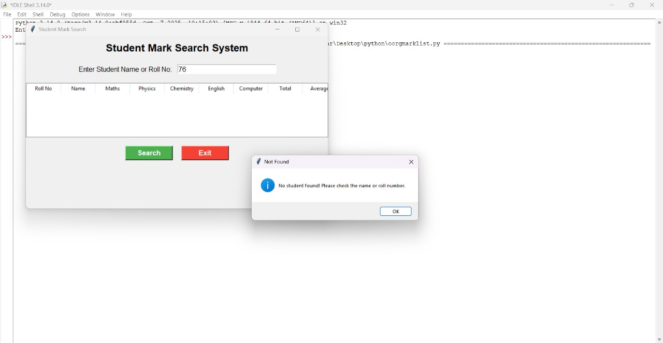

5. Conclusion

The Student Mark List Management System offers a practical and reliable solution for managing academic records in a structured digital format. By automating mark entry and result calculation, it reduces manual workload and improves accuracy. Its straightforward design makes it suitable for educational institutions seeking an efficient way to handle student performance data, while also laying the groundwork for future enhancements and integration.

